Hydrogen maser clocks

Definition:
# Source: AI Source: Provided by: [Data Path: Persons Table -> ID Column: 1, Name_En Column: Motasem Essam] -> From: [ChatGPT] on [1/26/2026]
Hydrogen maser clocks are a type of atomic clock that use hydrogen atoms to keep extremely stable time, especially over short periods. They are among the most stable clocks available and are often used in scientific research and space applications.

How hydrogen maser clocks work
# Source: AI Source: Provided by: [Data Path: Persons Table -> ID Column: 1, Name_En Column: Motasem Essam] -> From: [ChatGPT] on [1/26/2026]
- Hydrogen atoms as the reference
  - Hydrogen atoms have a specific frequency of energy transitions between two states.
  - This frequency is extremely stable in the short term.
- Microwave excitation (maser principle)
  - “Maser” stands for Microwave Amplification by Stimulated Emission of Radiation.
  - The clock uses microwave signals to excite hydrogen atoms and detect their natural oscillation.
- Counting vibrations
  - The oscillations of hydrogen atoms are counted electronically to generate a precise time signal.

Key Features
# Source: AI Source: Provided by: [Data Path: Persons Table -> ID Column: 1, Name_En Column: Motasem Essam] -> From: [ChatGPT] on [1/26/2026]
- Extremely stable short-term: better than cesium or rubidium for periods of seconds to days.
- Very high precision: suitable for scientific applications like VLBI (Very Long Baseline Interferometry) in astronomy.
- Less commonly used alone for UTC: often combined with cesium clocks for long-term accuracy.

Common Uses
# Source: AI Source: Provided by: [Data Path: Persons Table -> ID Column: 1, Name_En Column: Motasem Essam] -> From: [ChatGPT] on [1/26/2026]
- Astronomy and deep-space navigation
- Satellite timing and GPS references
- High-precision research laboratories
- Backup systems in atomic time standards

Comparison with other atomic clocks
# Source: AI Source: Provided by: [Data Path: Persons Table -> ID Column: 1, Name_En Column: Motasem Essam] -> From: [ChatGPT] on [1/26/2026]
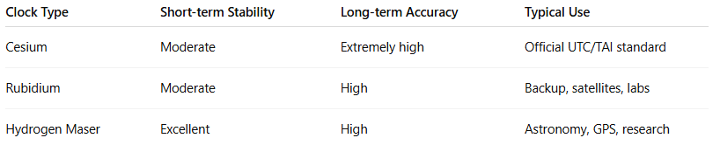
Clock Type | Short-term Stability | Long-term Accuracy | Typical Use
Cesium | Moderate | Extremely high | Official UTC/TAI standard
Rubidium | Moderate | High | Backup, satellites, labs
Hydrogen Maser | Excellent | High | Astronomy, GPS, research

✅ Summary:
# Source: AI Source: Provided by: [Data Path: Persons Table -> ID Column: 1, Name_En Column: Motasem Essam] -> From: [ChatGPT] on [1/26/2026]
A hydrogen maser clock is an atomic clock that uses hydrogen atoms to generate an extremely stable short-term frequency, making it ideal for scientific, space, and satellite applications, often combined with cesium clocks for long-term accuracy.

